Using MS Word to Produce Assignments

**MS Word 2013**

Contents

Styles 1

Modify a Style 2

Page Breaks/Section Breaks 3

Insert a Manual Page Break / Section Break 3

Page Numbering 4

Table of Contents Pages 5

Indexes 6

Creating Index Entries 6

Create an Index Page 7

Index 8

## 

## Styles

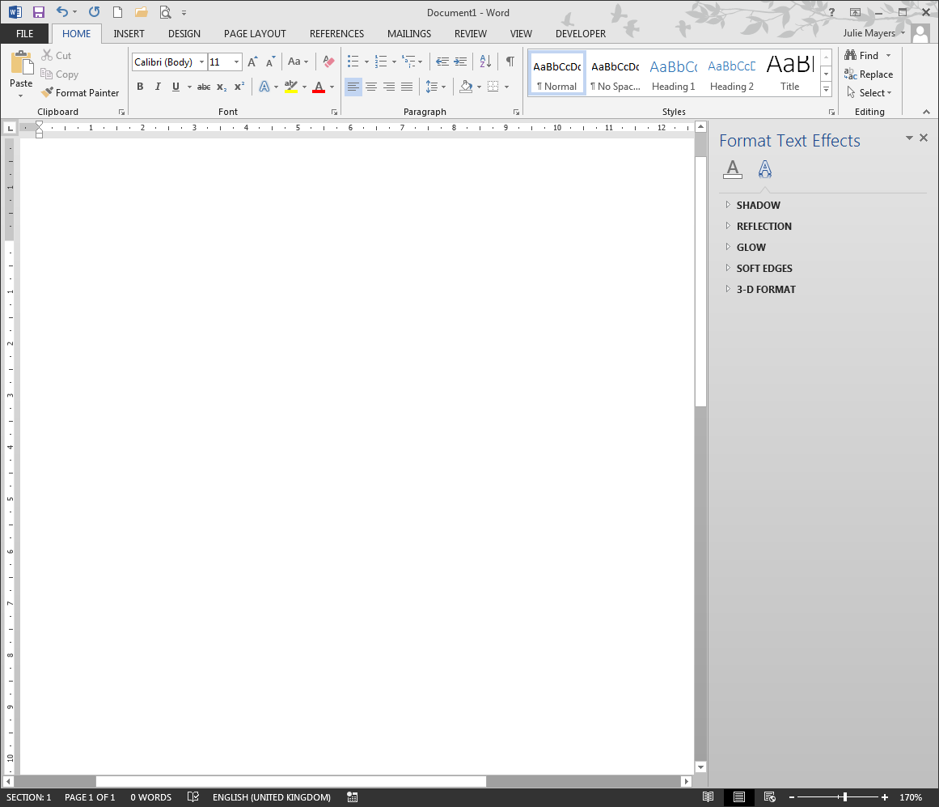Styles are pre-created formats consisting of paragraph and font formats. When they are applied, text will be formatted accordingly. Styles also ensure that formatting is consistent throughout a document.

* 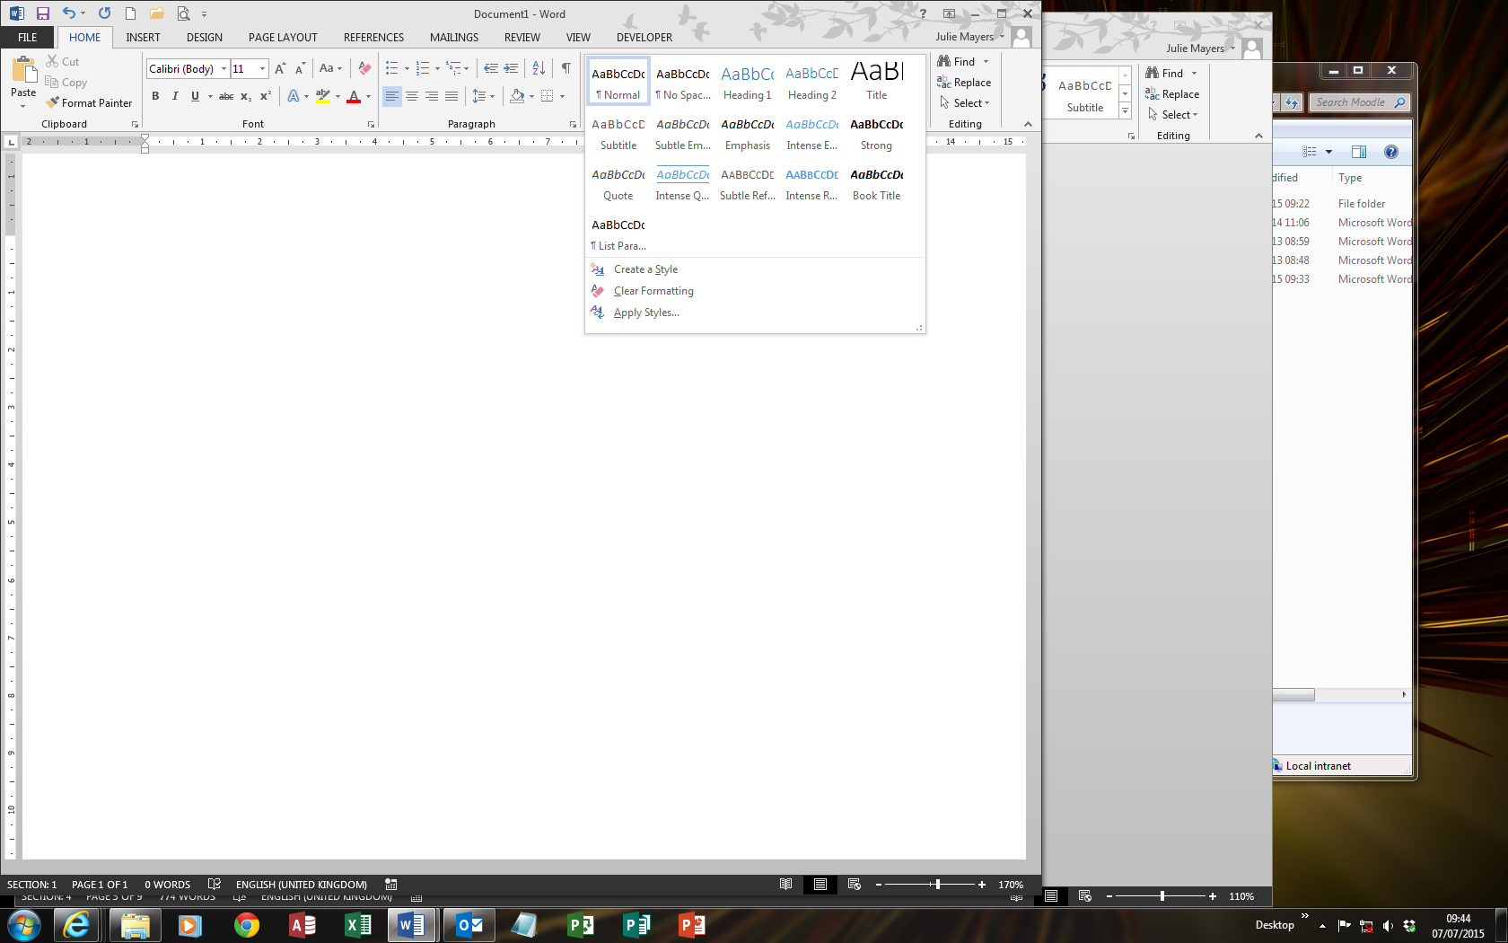From the Home tab, select the **more** arrow on the right of the Styles

To Create a New Style

* Select the formatted text
* 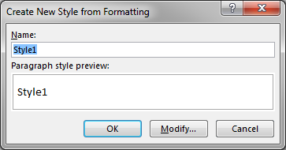As above, select the **more** arrow from Styles and select **Create a Style**
* From the **Create New Style from Formatting** give your newly created style a name, ie Style1
* Then click **Modify** to modify your style
* 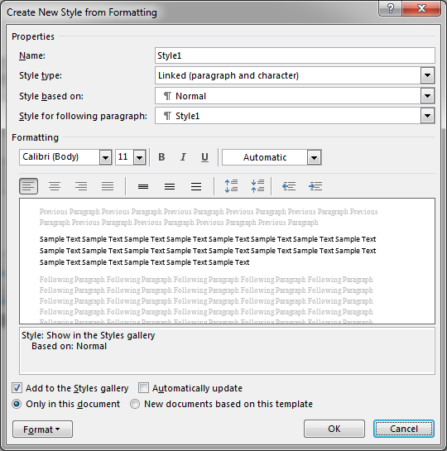If the selected text has already been formatted then this will appear on the formatting screen; otherwise select the formatting options that you want, clicking **Format** for more options
* OK

### 

### Modify a Style

* Right click on the heading to be modified and choose **Modify**
* Update the formatting and select OK

## Page Breaks/Section Breaks

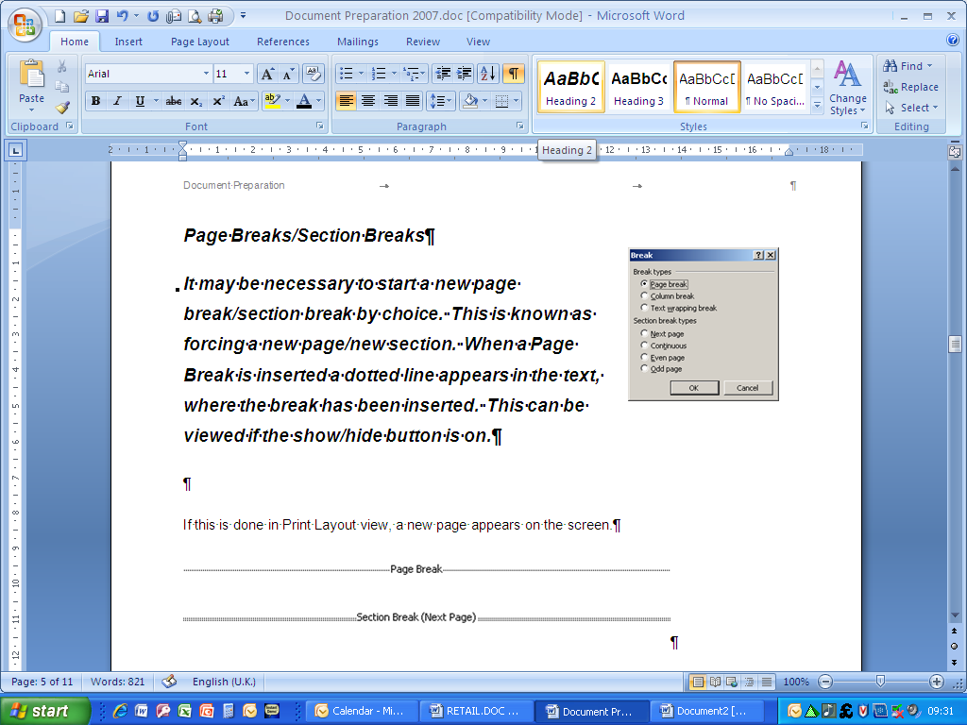It may be necessary to start a new page break/section break by choice. This is known as forcing a new page/new section. When a Page Break is inserted a dotted line appears in the text, where the break has been inserted. This can be viewed if the show/hide button is on. (see Home tab, Paragraph group)

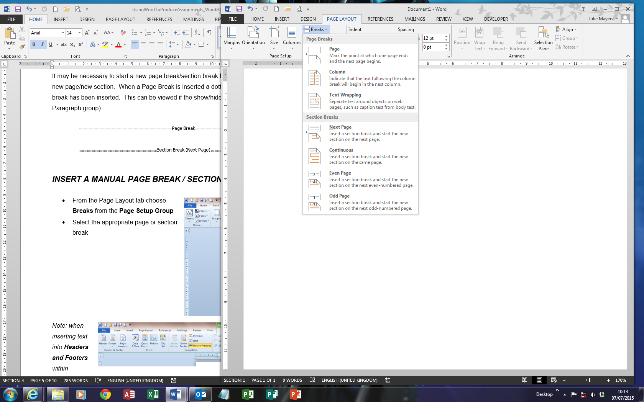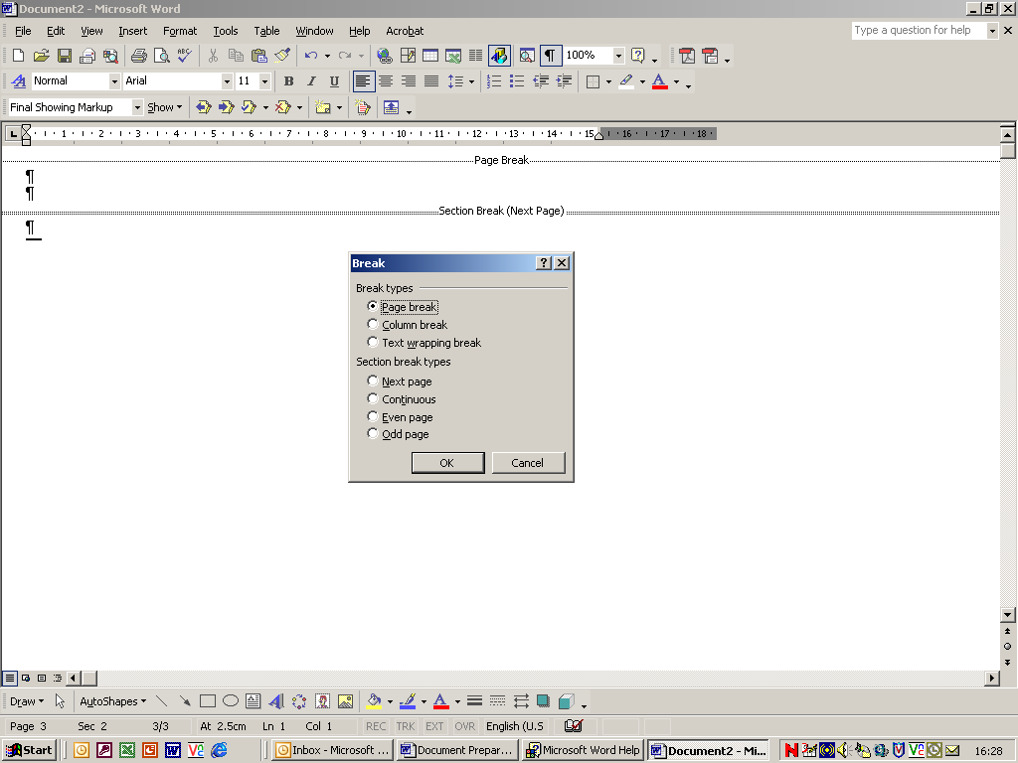

### Insert a Manual Page Break / Section Break

* From the Page Layout tab choose **Breaks** from the **Page Setup** Group
* Select the appropriate page or section break

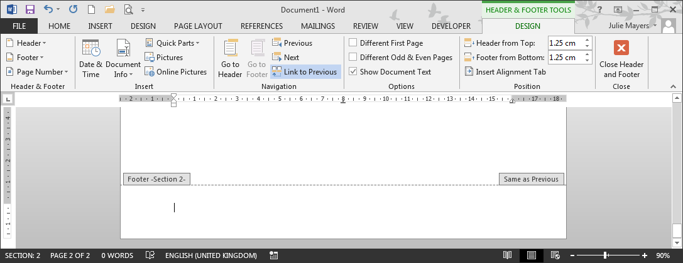*Note: when inserting text into* ***Headers and Footers*** *within Sections always be aware of the* ***Same as Previous*** *option. To take off the* ***Same as Previous*** *option, deselect the* ***Link to Previous*** *option. This enables you to put different text into different sections. If all the sections are to contain the same header/footer, leave the* ***Same as Previous*** *option on.*

## Page Numbering

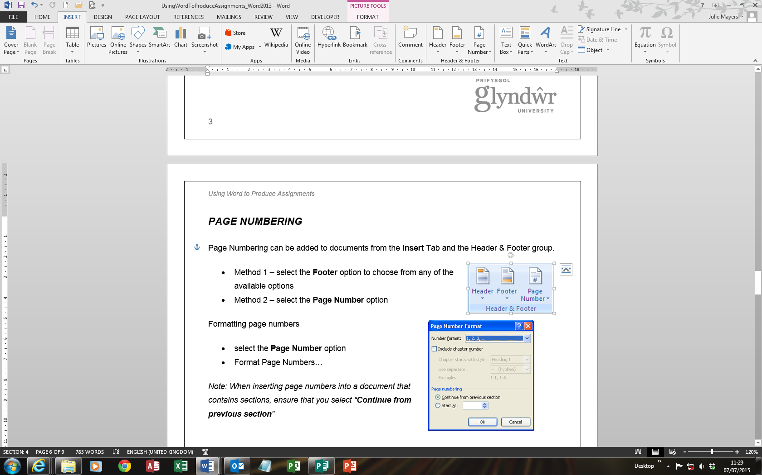Page Numbering can be added to documents from the **Insert** Tab and the Header & Footer group.

* Method 1 – select the **Footer** option to choose from any of the available options
* Method 2 – select the **Page Number** option

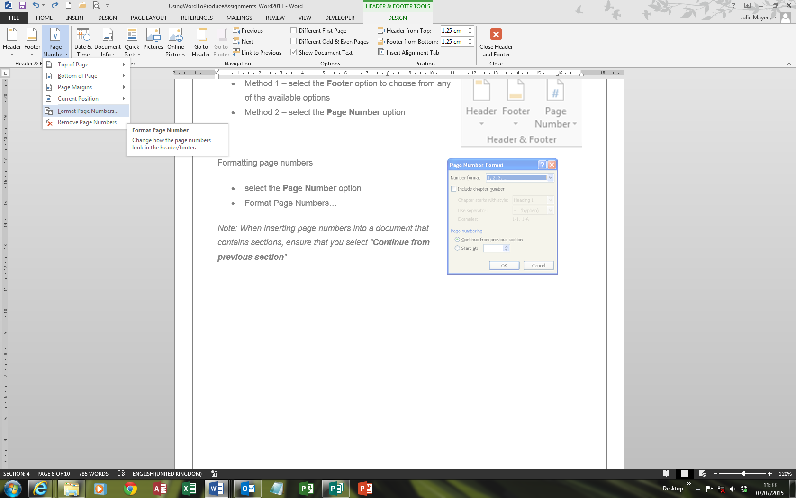Formatting page numbers

* From the header/footer section select the **Page Number** option
* Format Page Numbers…
* From here you can select the Number format

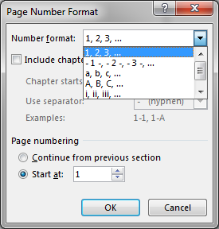*Note: When inserting page numbers into a document that contains sections, ensure that you select “****Continue from previous section****”*

## 

## Table of Contents Pages

When styles have been created and applied to a document, it is a simple task to create **Table of Contents**, and **Indexes**. Once these tables are created, they can automatically be updated, if any of the information is changed.

* Click where you want to insert the table of contents.
* Select the **References** tab and click **Table of Contents**, and choose a design
* For more options select   
  **Custom Table of Contents**

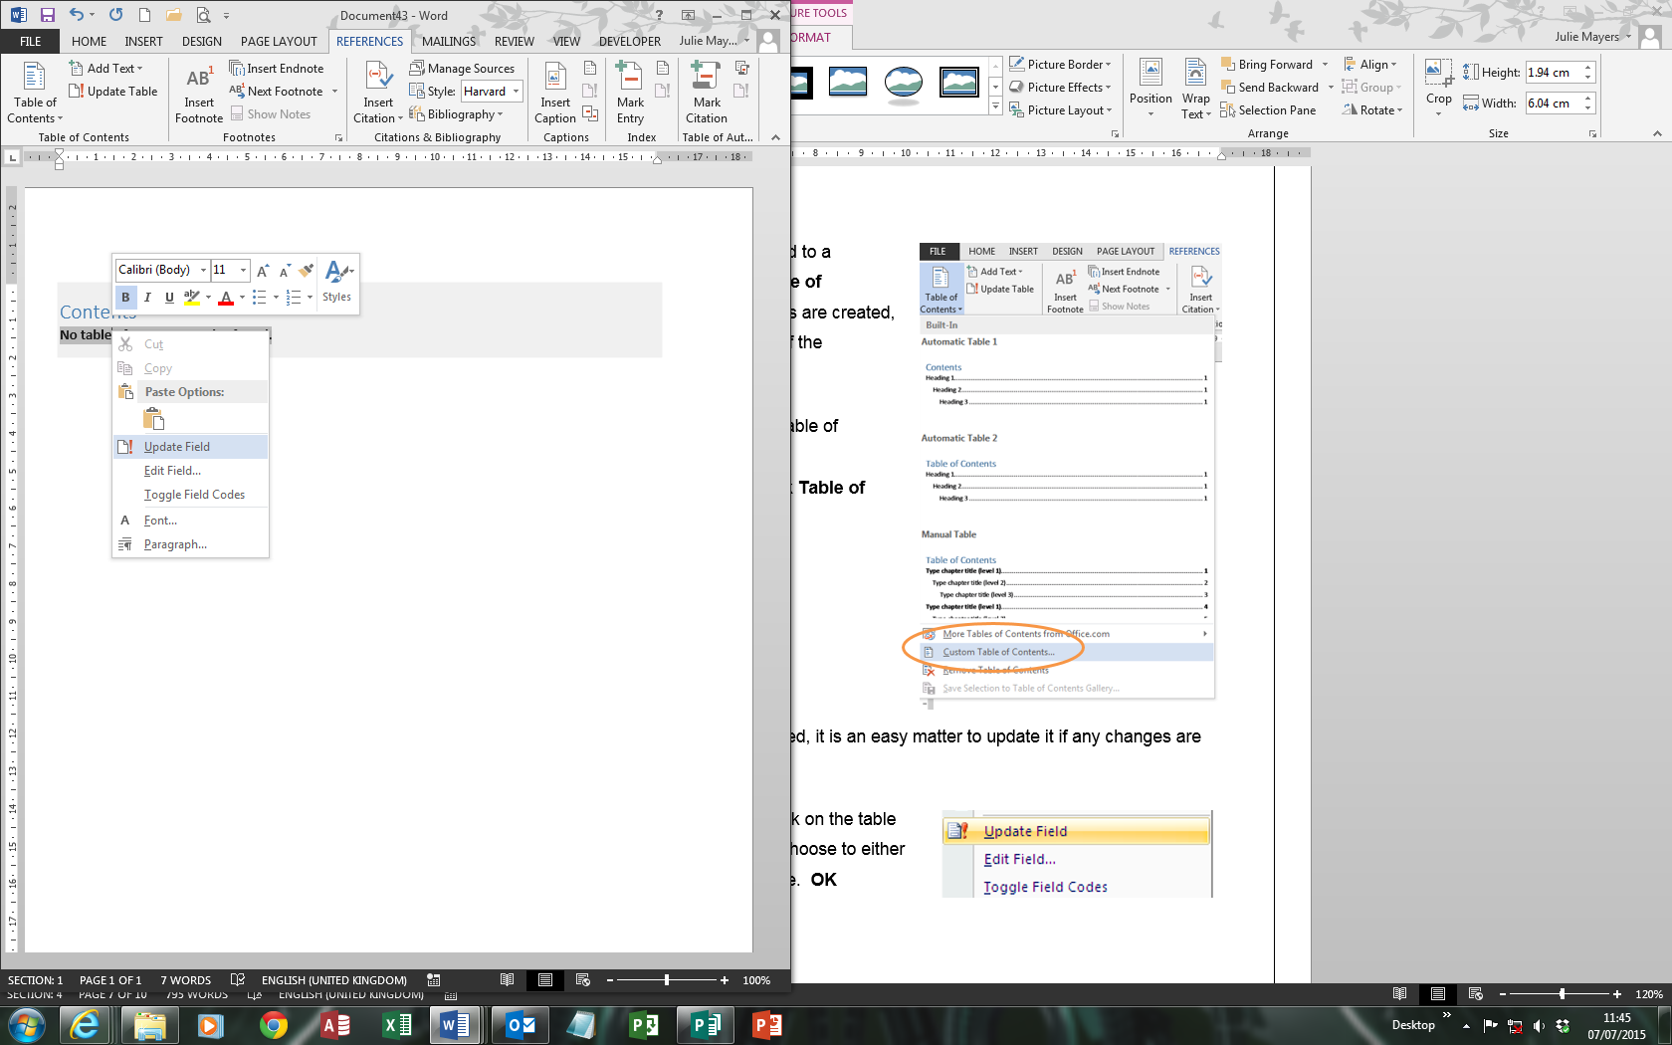Once a **Table of Contents** has been created, it is an easy matter to update it if any changes are made to the contents themselves.

To update the **Table of Contents**, right click on the table and choose **Update Field** (or press F9). Choose to either update the page numbers of the entire table. **OK**

## Indexes

### Creating Index Entries

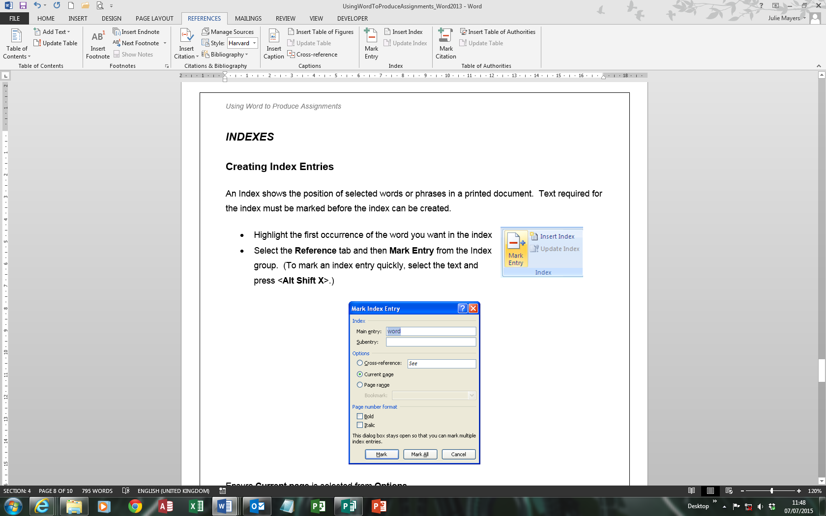An Index shows the position of selected words or phrases in a printed document. Text required for the index must be marked before the index can be created.

* Highlight the first occurrence of the word you want in the index
* 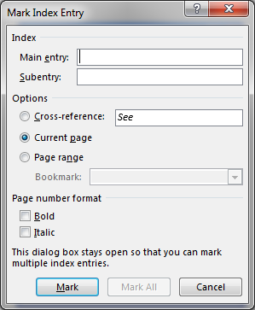Select the **Reference** taband then **Mark Entry** from the Index group. (To mark an index entry quickly, select the text and press <**Alt Shift X**>.)

Ensure **Current page** is selected from **Options**.

Click **Mark All** to create an index entry for all occurrences of Keyboard. The index entry is shown as a field, beginning with **XE**

Click **Close** to remove the dialog box. Scroll through the document. An index mark appears next to every occurrence of the word selected.

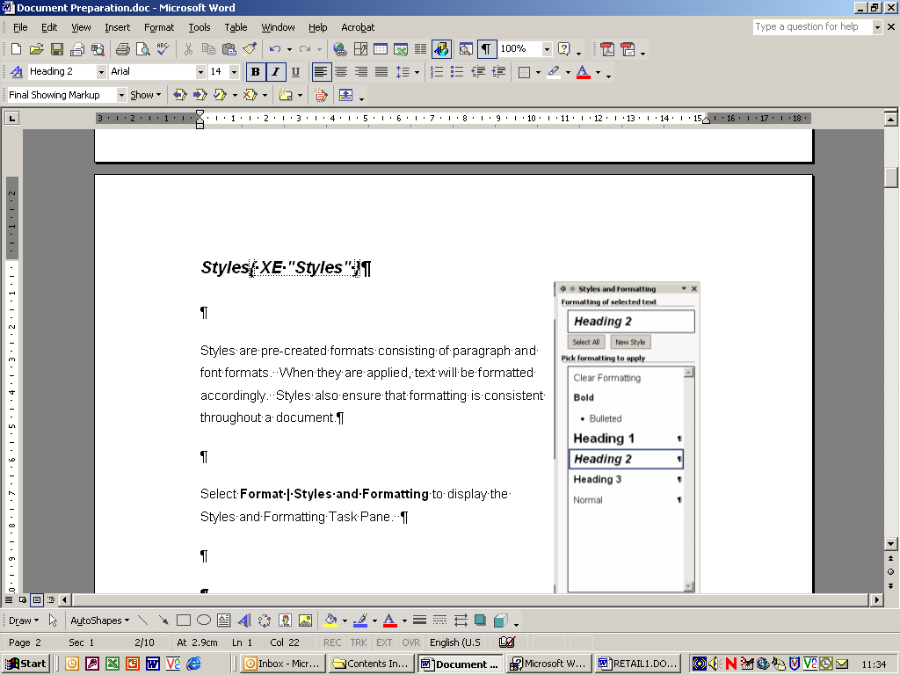

Note: If you don’t see **XE** fields, click Show/Hide icon from the Home tab – Paragraph group

### Create an Index Page

* Click where you want to insert the index page.
* From the **Reference** tab select **Insert Index** from the Index group.
* 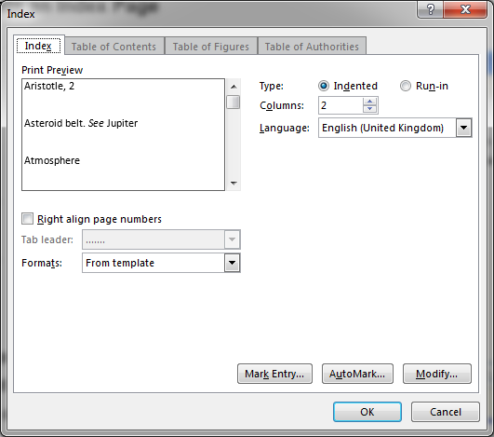Ensure that you are on the Index tab
* Select the format. **OK**

To update the index to show the edited entry, click anywhere in the table and press <**F9>**

## Index

Create an Index Page, 7

Creating Index Entries, 6

F9, 5, 7

*Headers and Footers*, 3

Indexes, 5, 6

Insert Index, 7

Modify a Style, 2

New Style, 1

Page Break, 3

Page Breaks, 3

Page Numbering, 4

*Same as Previous*, 3

Section Break, 3

Section Breaks, 3

Styles, 1

Table of Contents, 5