Basic Spreadsheets

**MS Excel 2013**

# Basic Excel

1. Start a new workbook. The worksheet below contains data on boxes of fruit. Insert the following information in the cells indicated.

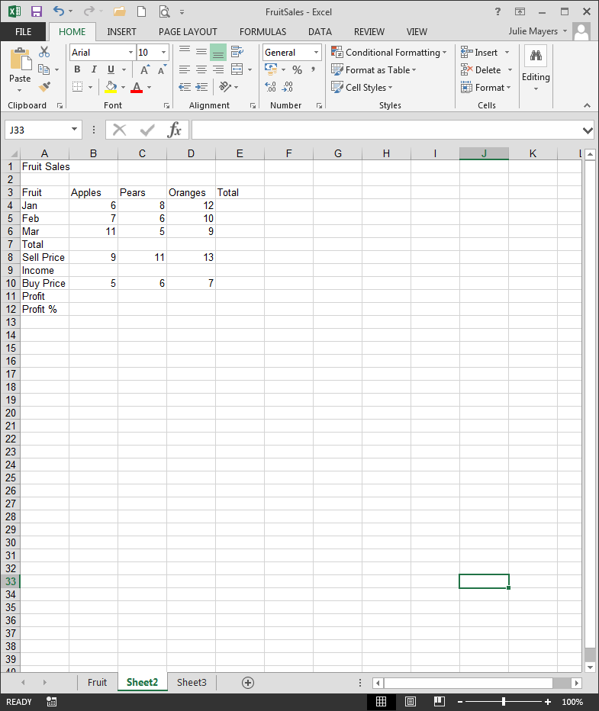

1. 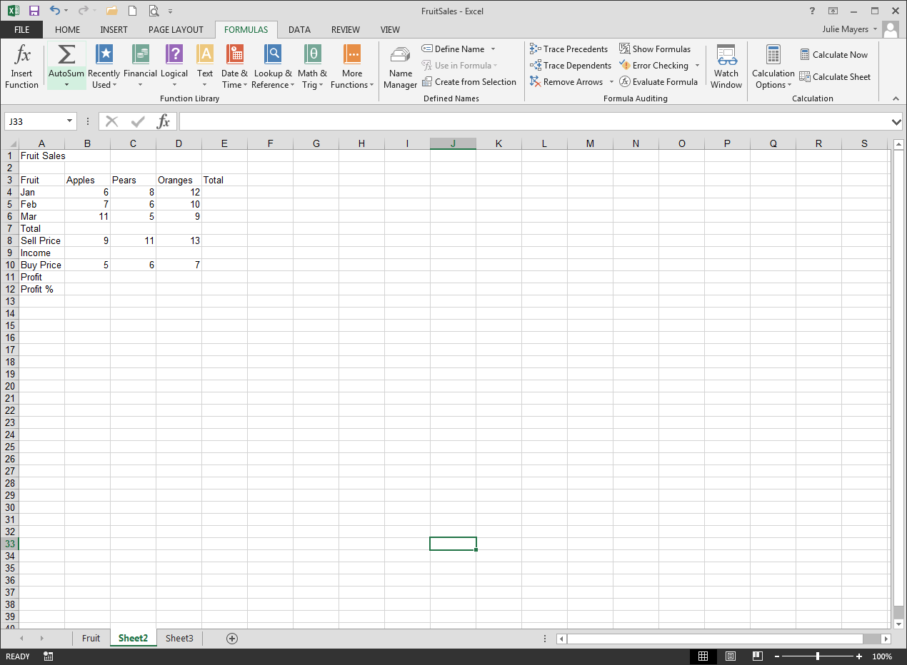From the **Formula** Tab, use the **AutoSum** to sum the sales for each fruit (in **Row 7**) and for each month (in **Column E**). Calculate a grand total in cell **E7** (using either the columns totals to the left or the row totals above).
2. The **Income** row needs to contain a formula that multiplies the **Total** by the **Sell Price.** In cell B9 type =B7*B8
3. The **Profit** is a more complicated formula, containing brackets. Work out the profit for one box of fruit using subtraction in brackets and multiply by the total number of boxes sold. In cell B11 type =(B8-B10)*B7
4. Use **AutoSum** to calculate the total income in cell **E9**, and total profit in cell **E11**.
5. Check all the formulas by double clicking on each in turn and then save the completed working as **FruitSales**.

## Excel Answers

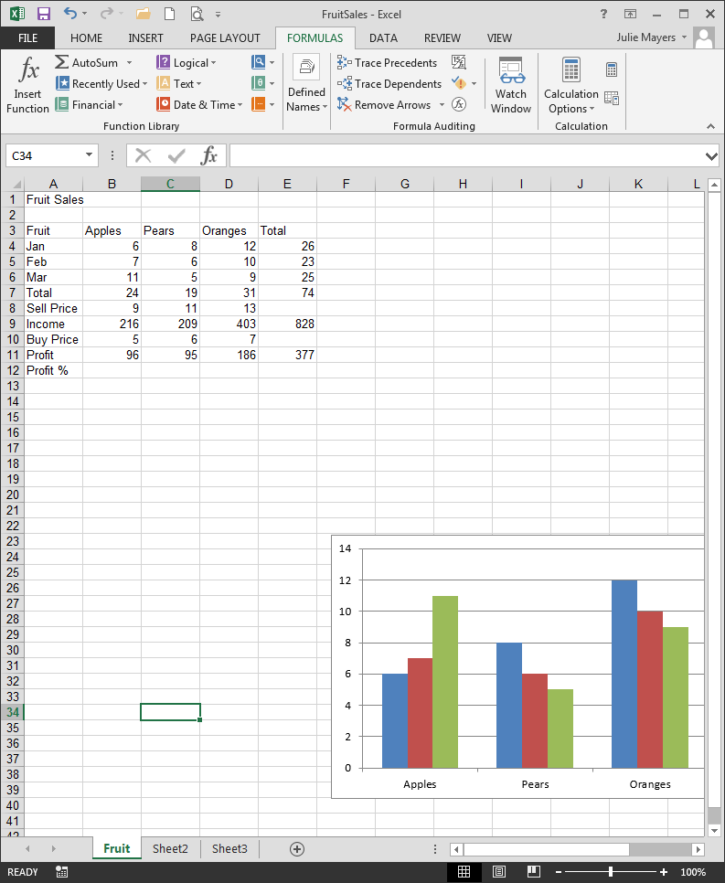

## Excel Answers showing formulas

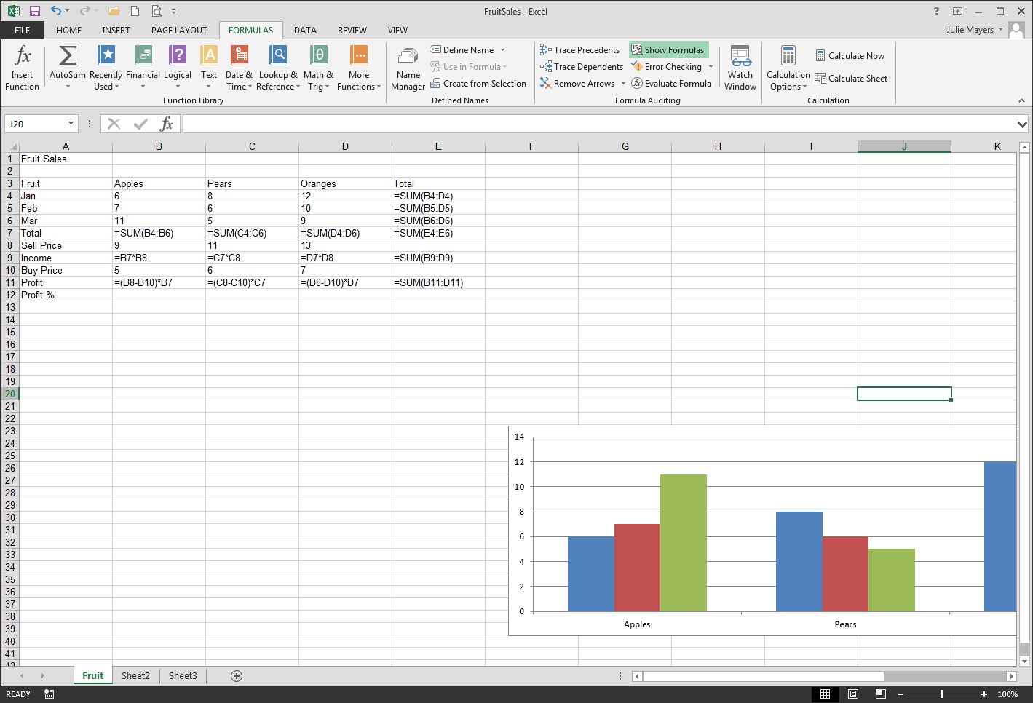

# Other Formulas

# 

# Guidelines

## Format Cells

* Home tab | Number group | choose drop down arrow

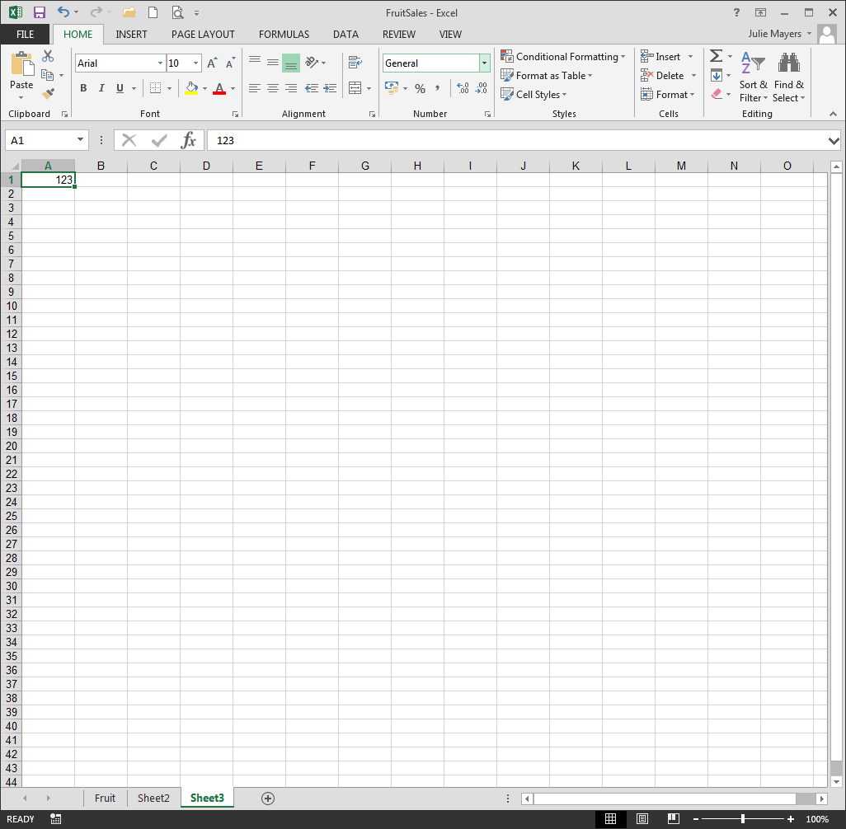

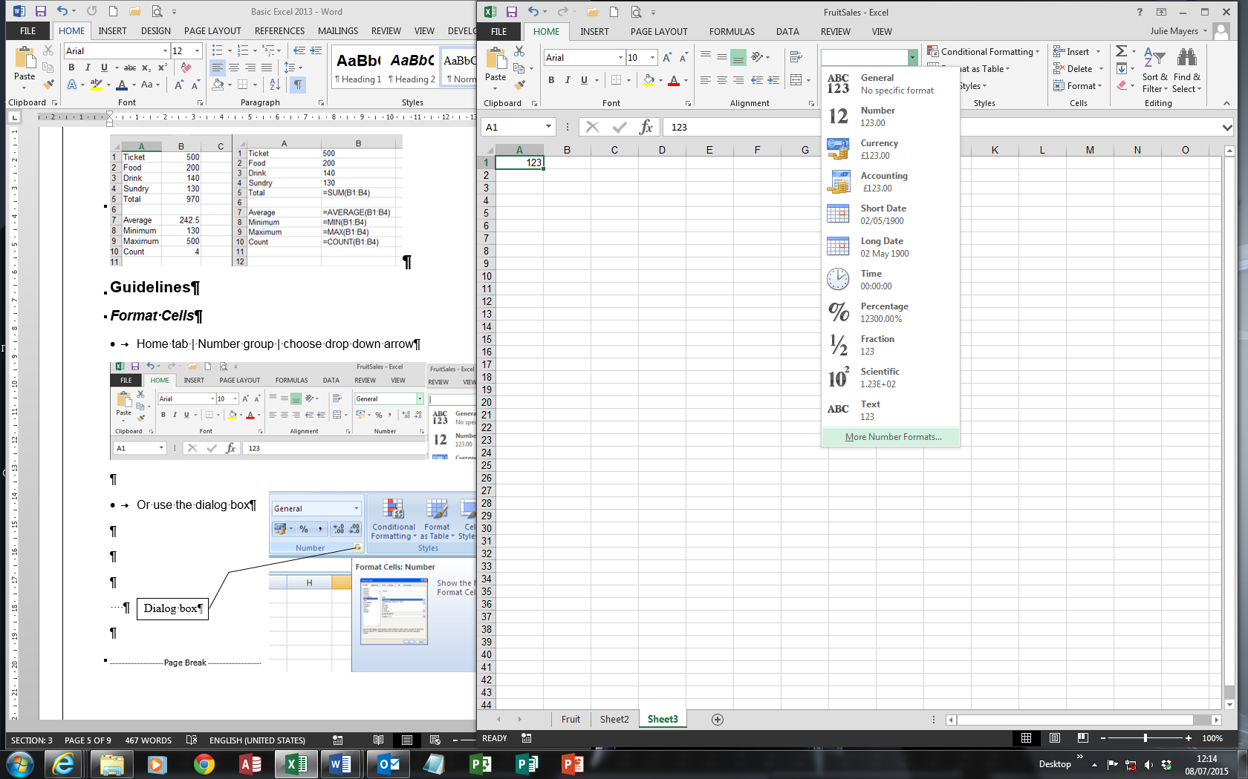

# Page Layout

To change the appearance of the worksheet before it is printed select **Page Layout**.

## Scale to Fit

* Use the **Scale to Fit** group to fit the worksheet to a set number of pages.

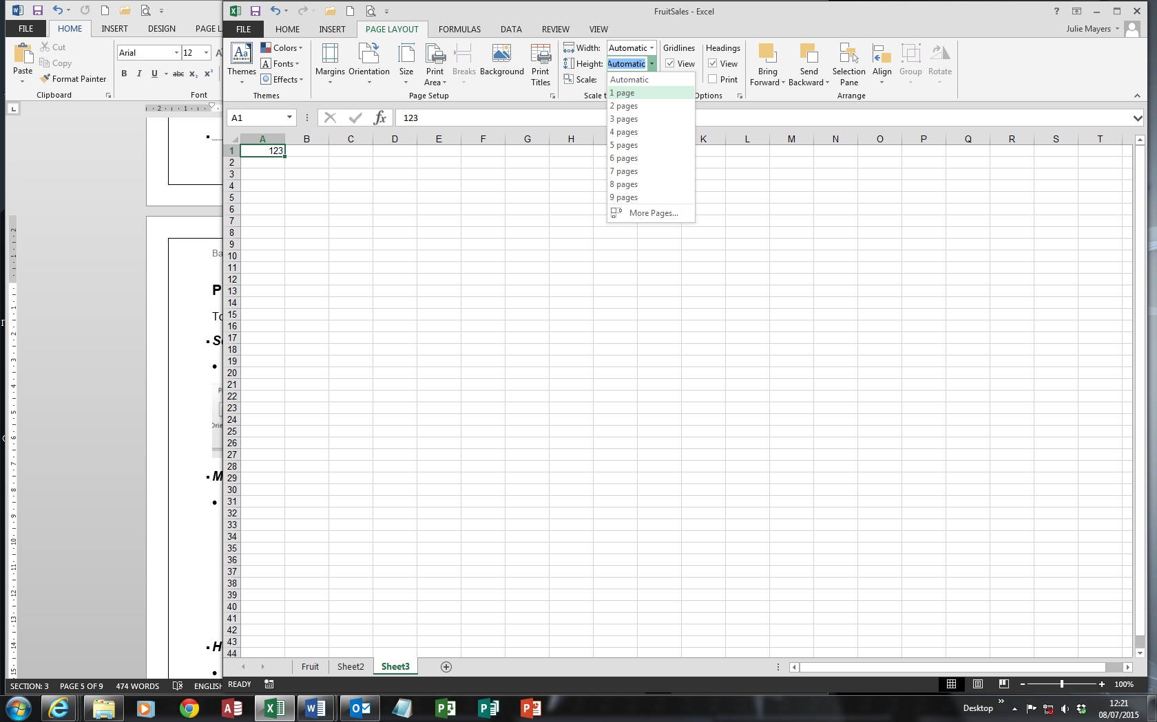

## Margins

* **Margins** can be reduced or enlarged to give more or less white space around a worksheet. Margins are normally reduced to allow more of a worksheet to fit on each piece of paper.

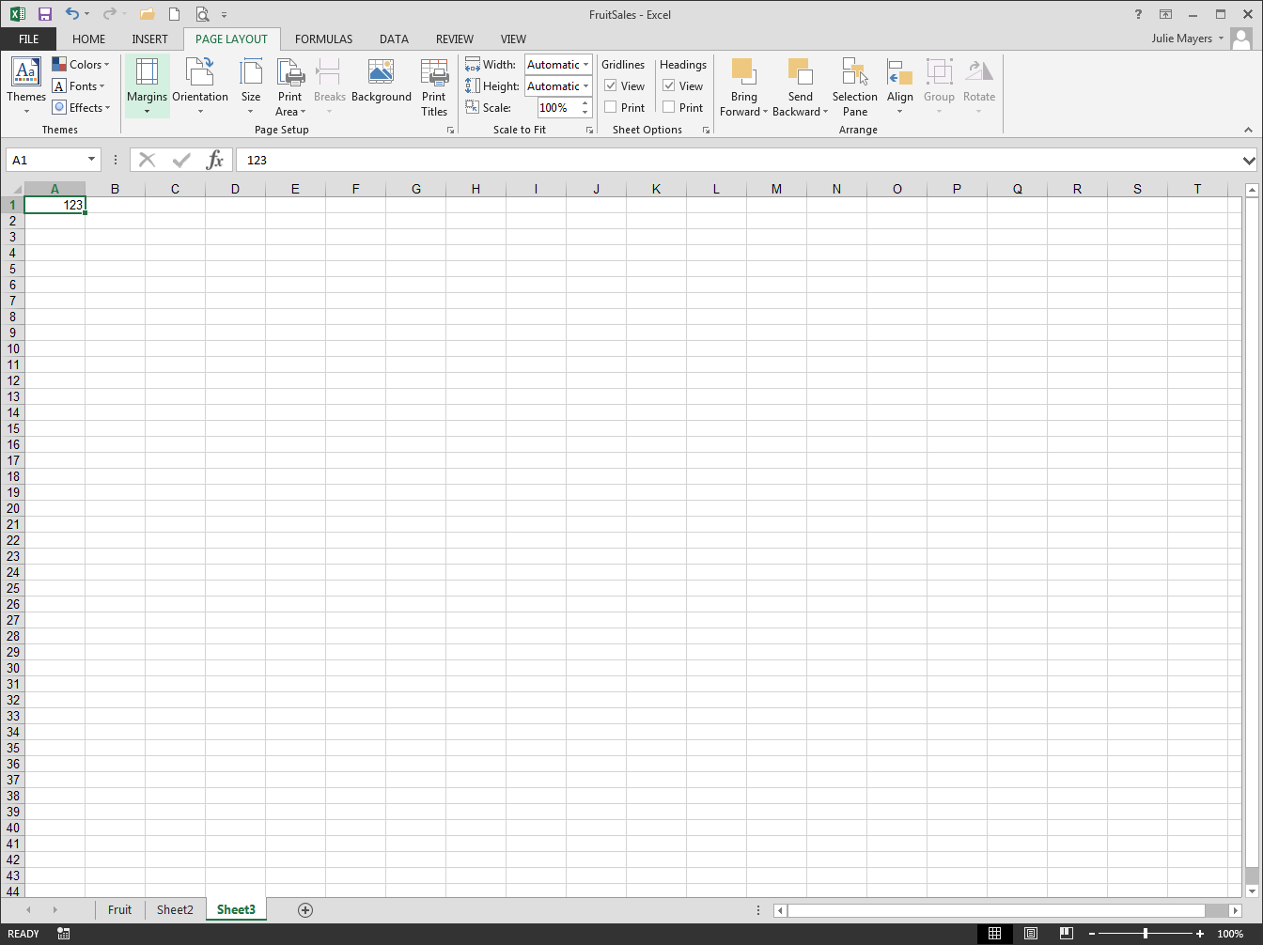

## Headers and Footers

* **Headers** and **Footers** are lines of text at the bottom/top of every printed page. This can be found on the **Insert** tab inside the Text group

## Print Titles

* **Print Titles** – Rows and columns of the worksheet (usually containing labels) may be specified as titles, and these will be printed on each printed page.

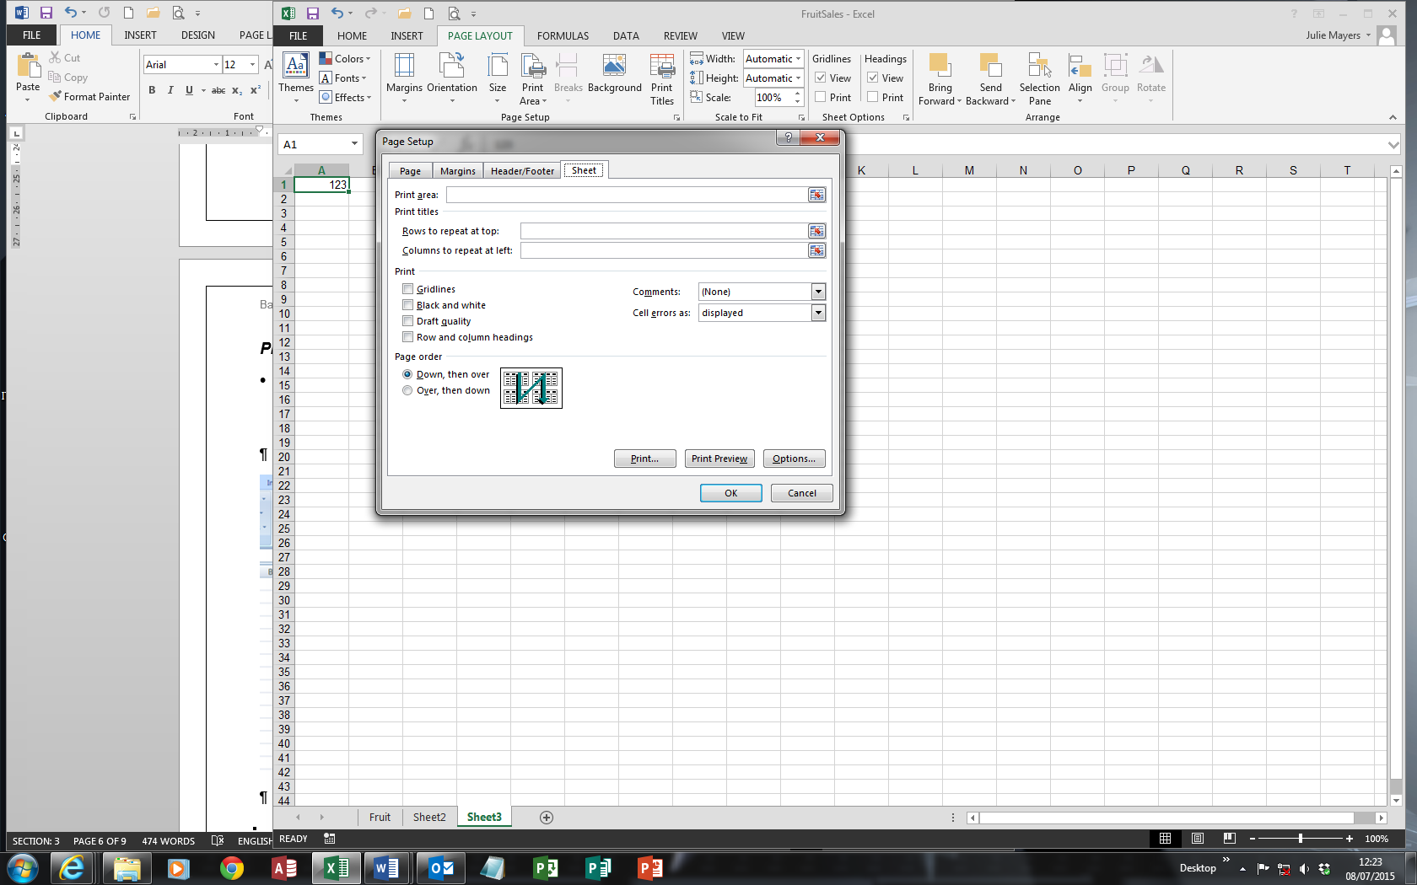

# Merging cells

From this 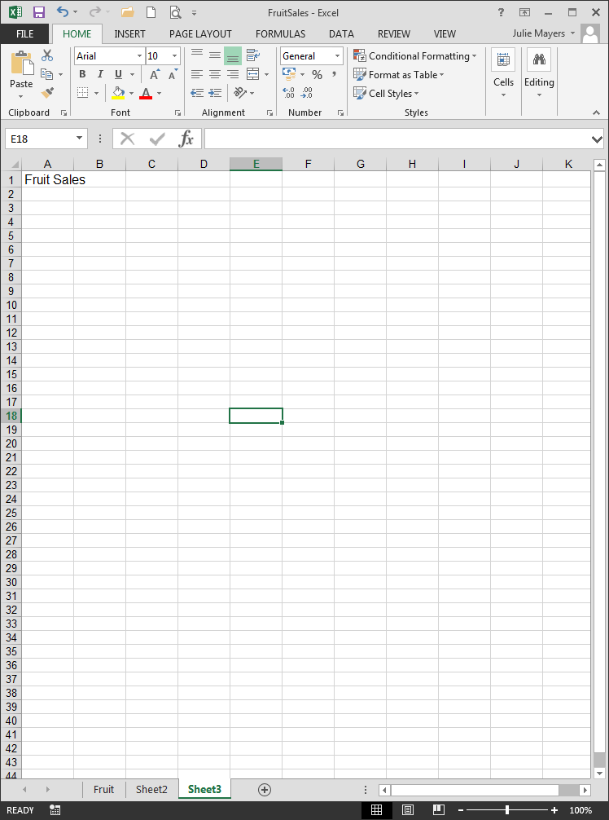

To this 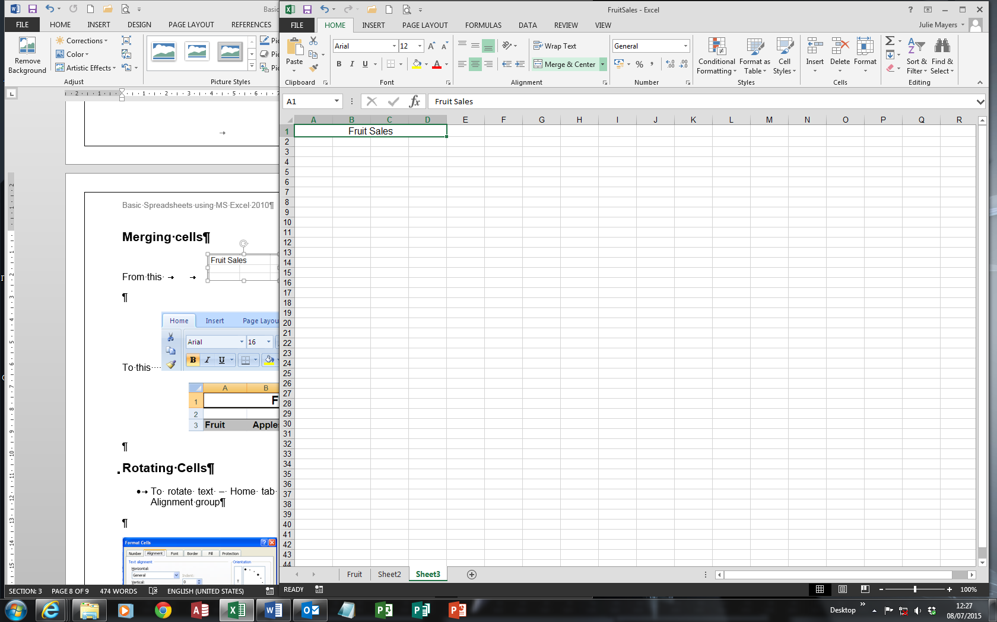

# Rotating Cells

From this 

To this 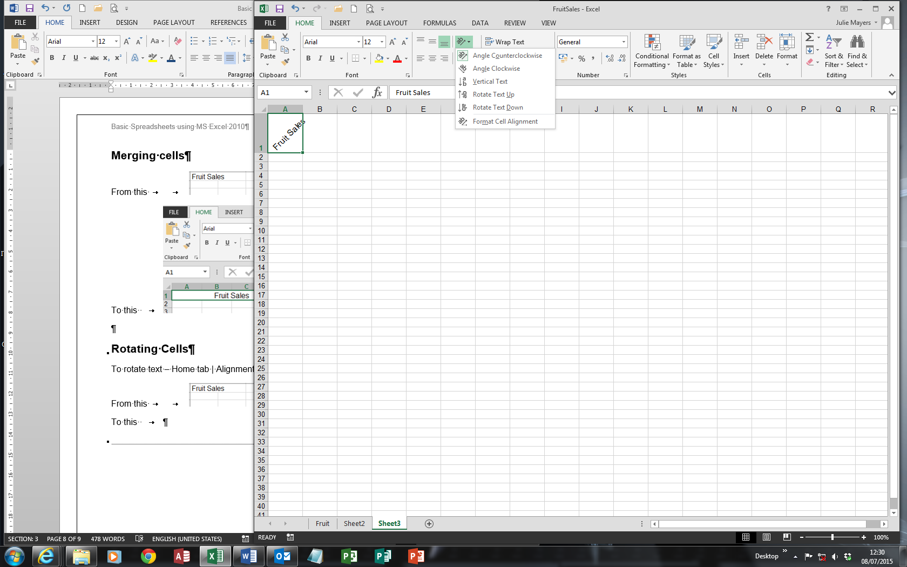

# Charts

1. 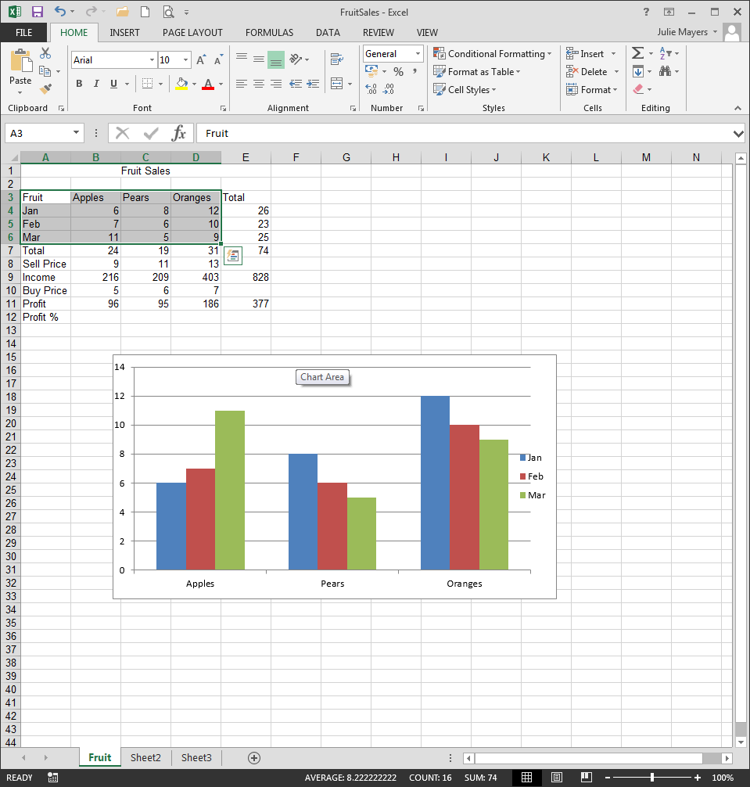Open the workbook **FruitSales** (which was created on page 1). When creating a chart always select the data before stating (A3:D6).
2. 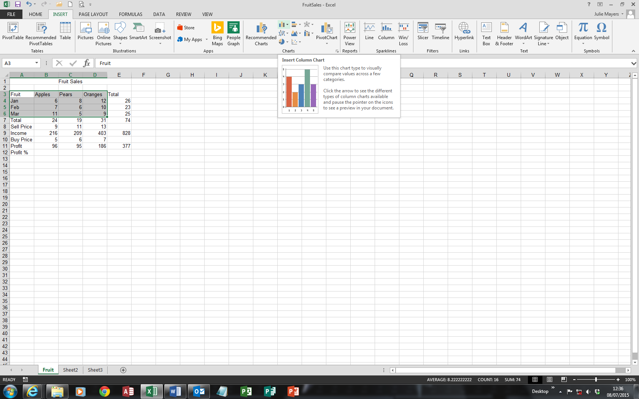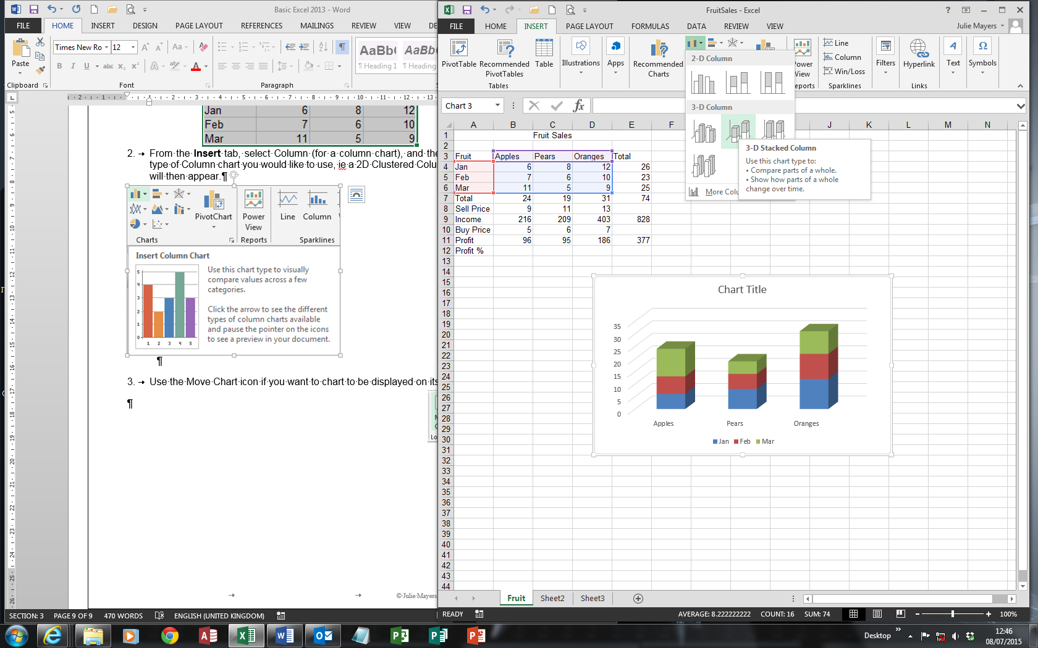From the **Insert** tab, select Column (for a column chart), and then choose the type of Column chart you would like to use, ie a 2D Clustered Column – the chart will then appear.
3. Use the Move Chart icon from the Design tab if you want to chart to be displayed on its own sheet

